**How to search for Lead Killed reason from Advanced Search with Search Tab in Sales**

Advanced Search Feature within the Search Tab in Sales Application is very handy for those specific searches of fields that are not available in basic Search.

FranConnect system gives you the flexibility to review the data and run an export report of these search features.

In a recent case study, it was asked how to search for leads with a “Dead Status” showing various reasons under “Lead Killed Reason”

You can start of under **Sales.**

1. Click **Search Tab**--> **Select Active or Archived leads** from the criteria.
2. Click Advanced Search

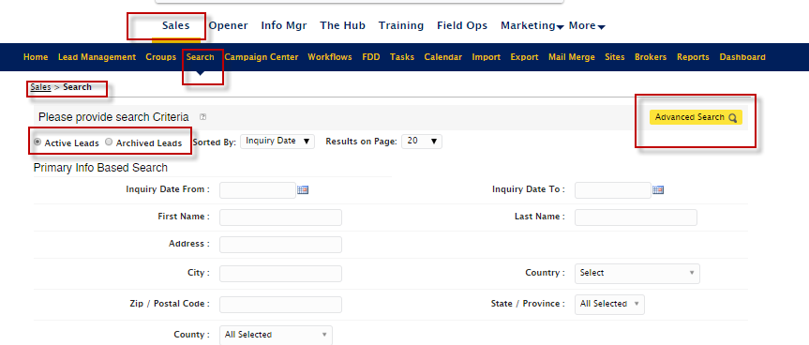

1. Select any additional sections as Primary Info is already selected by default and Search Data.

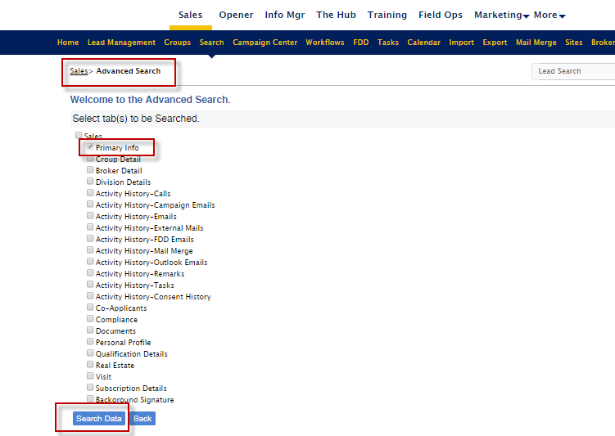

1. Scroll a bit and select the **Status** and **Lead Killed Reason**

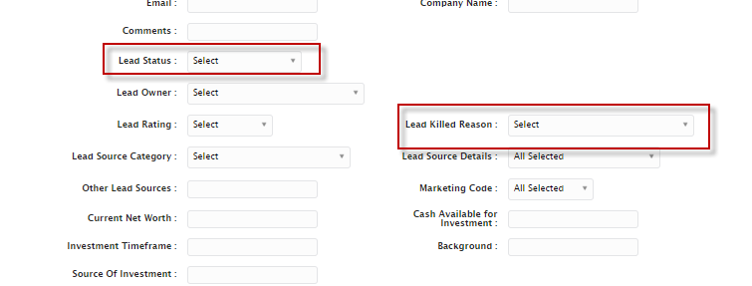

Additional you can view data and export to excel as desired