**Activating Terminated Franchise Locations in Admin**

A successful organization is always looking to develop business all over the country and internationally. And at times, locations would need to be activated while it may be temporarily terminated.

In support of the changes and growth, FranConnect system provides the flexibility to change the status of location.

In this article, we will discuss about activating terminated locations in **Admin**.

1.From **Admin->Franchise Location,** Select Franchise Status as **Terminated** and click **Search**.

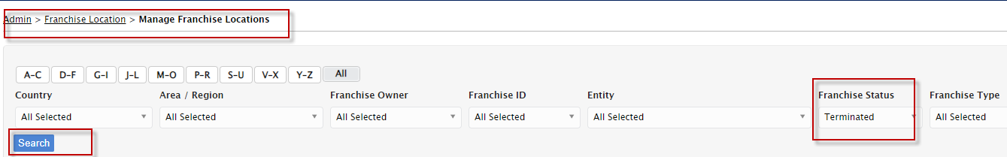

2- Hover Actions Gear Tool to click **Activate** the desired Franchise ID.

