**Lifecycle and detailed description of the difference between an account, leads, contacts and opportunity in CRM.**

In FranConnect, under CRM application, there are various tabs such as Lead, Contact, Accounts, Opportunity and Transaction.

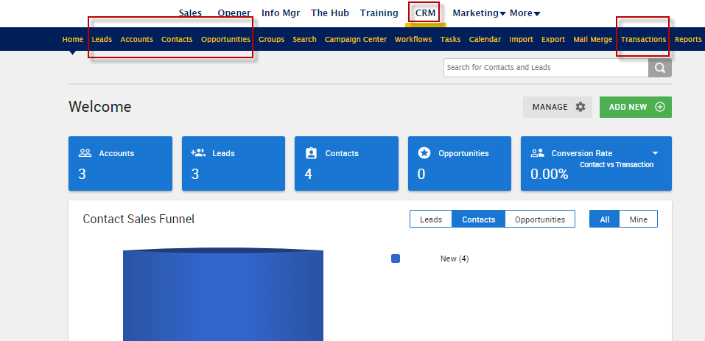

These are some of the common Business Terms used in Franchising while some of these are interchangeable.

The Lifecycle of a customer in CRM will typically follow this flow:

1. New **Lead** = Form fill on a website or call in
2. Lead Nurturing with Campaigns and qualification steps
3. Convert to **Contact** = Qualified Lead that you want to engage with on a sales cycle
4. Continue to nurture the contact and follow your sales process.
5. Associate Contacts with **Accounts** when necessary for high-level roll-up.  For Example, an Account can be the Company that you are working with and the Contacts can be the individuals within that company that you are working with.
6. Create an **Opportunity** = You have identified the type of service the potential customer is interested in and you can now track your progress to close that opportunity.
7. Create a **Transaction**= Your Opportunity has converted to a sale and now you can track the closed sale for long term customer building