**Time to Initial Contact of a lead in Sales**

A successful organization is always looking to develop business all over the country and internationally. And communicating with leads is crucial for success in a fast-growing competitive world.

In support of these changes and growth, FranConnect’ s Dashboard Reports in Sales and other features now allow lead owners to review the initial contact made to leads.

In this article, we will discuss about reviewing the Dashboard in **Sales**.

1.From **Franchise Sales🡪Dashboard**, from the drop down for **Switch to Dashboard**. select **Contact Report Dashboard**    
2. Select the filters: Inquiry Date and Status Category Active, you can see the Criteria:  
  
Leads Received  
Leads got zero phone calls  
Leads got one phone call  
Leads contacted within 0-30 minutes by phone call

Leads contacted within 30-60 minutes by phone call

Leads contacted within 60-180 minutes by phone call  
  
You can see results of the activity.  
  
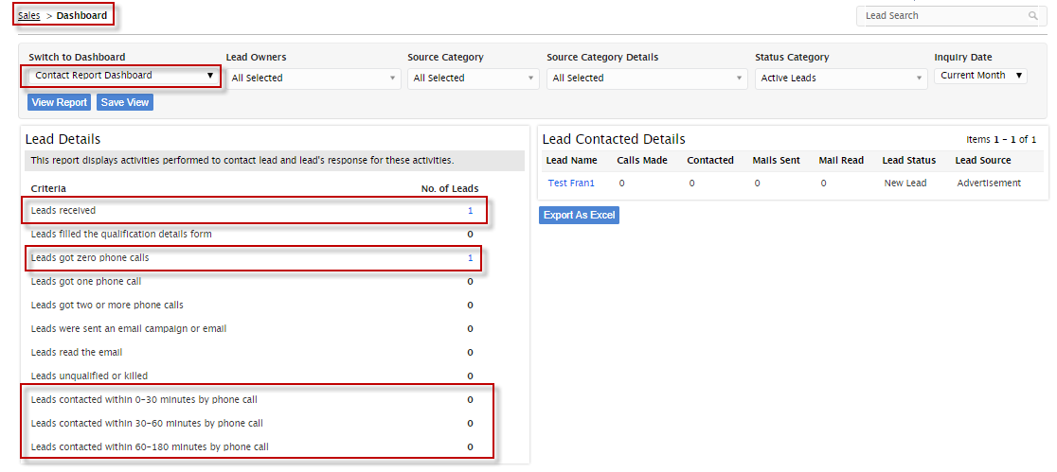

Another option is go to **Sales--> Reports**  
  
**Lead Contacted Details Report.**

This report shows Calls Made, Contacted and Mails Sent/Read against Leads in a given period.  
  
  
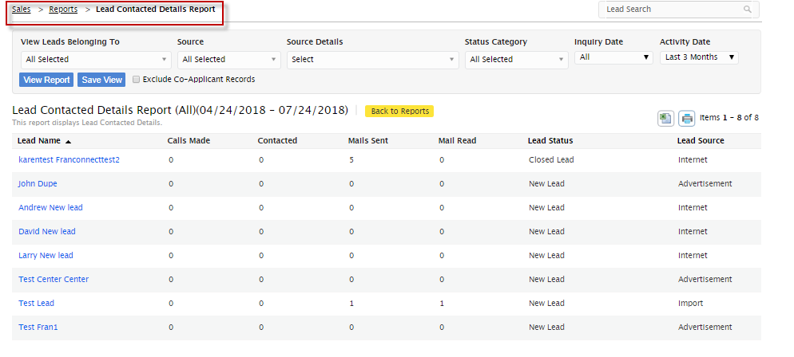  
  
Another report:  
Franchise Sales-> Reports--> **Track Inactive (without any activity) Leads report.**  
  
This report shows how the consultants / Lead Owners are engaging with leads through the contact activity in given time period.

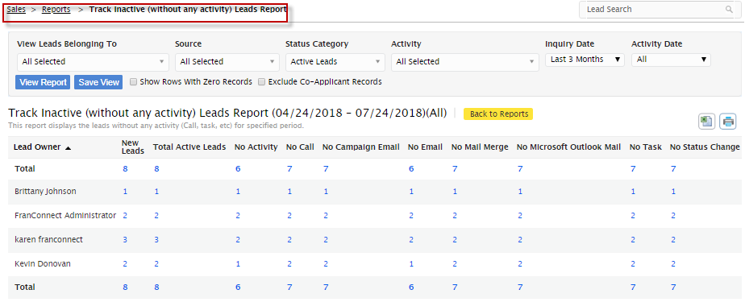  
  
Another report in Sales Report is **Lead Status Pipeline Reports** where you can see how long a lead was in system and then how long the lead was in a status.  
  
Lead (1/2) so 1 would be the number of days the lead had been in a status and 2 would be the number days the lead was in the system.

  
  
  
  
