**Configure Display Columns from Admin**

Organizations like to manipulate their FranConnect system with various Display Columns in the summary of any application such **Admin**, **Sales, Opener, Information** Manager and so on. They configure various fields by adding and removing Columns from **Admin**.

And they need to do this for easy access of data and information which saves time from multiple clicks.

FranConnect system is so easily customizable keeping the users at ease when retrieving and reviewing records.

In this article, we discuss about how to configure these fields from Admin.

You can start of by going under **Configuration** in **Admin**.

1.From **Configuration**-> **Configure Summary Display Columns.**

2. From the Page Name, Corporate Users, click on the Action Gear and select **Configure**

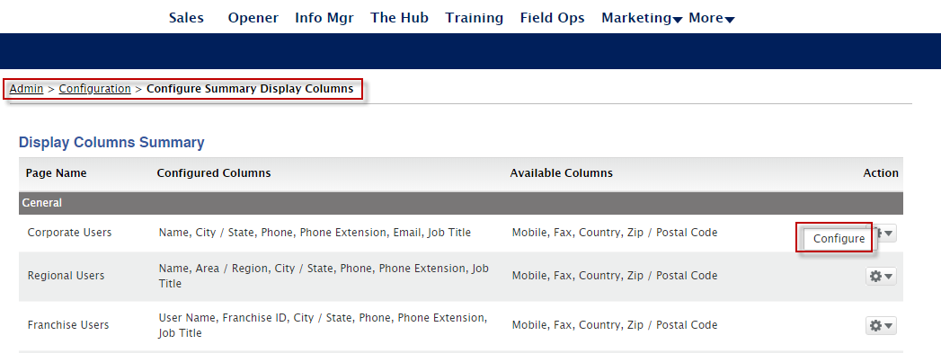

3. Select a field from the **Available Columns**, click the **>>,** move the field name to **Configured Columns.**

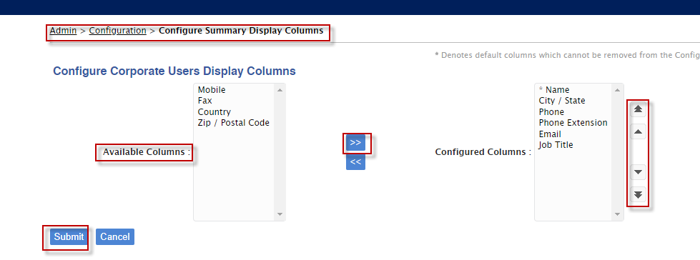

4. Click the side arrows to arrange the order.

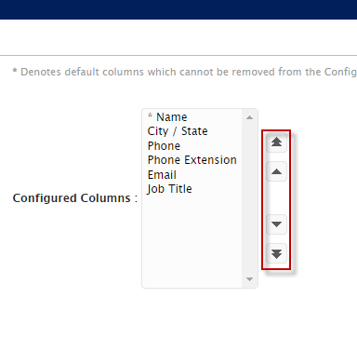

5. Click Submit.

You can see under Admin🡪 Users🡪 Corporate users, the field names are arranged.

