**Export Users in a Franchise system.**

Every now and then, you would want access or perform bulk updates of user accounts for the corporate or Franchisees.

During data cleanup you may find that exporting users is the best way to manage user accounts of the Franchise system.

This can be done by selecting the **Export** under the **Users** in **Admin**.

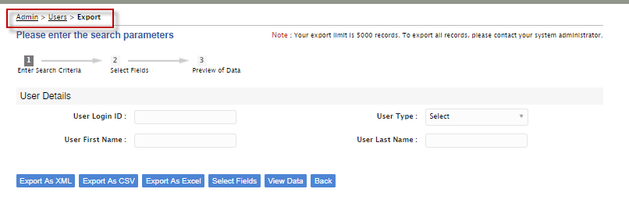

You can select the **User Type** and click **Export As Excel.**

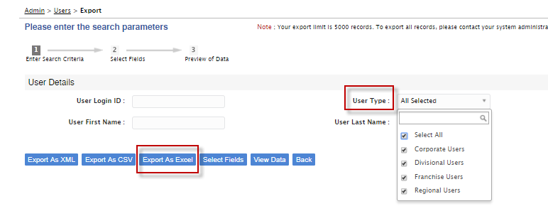

Additionally, you can **select Fields** and export.

