**Accessing Library Logs and News Logs in Admin**

In every organization, it is critical to ensure the employees and corporate users review and are up to date about various management policies and processes.

Corporate house these information under Library documents and News in FranConnect under **The Hub** application which makes it convenient for its users.

It also makes it equally convenient for Corporate to run audit checks on their users and to measure the utilization of these Library Documents and News.

For example, when an employee leaves the organization, the corporate administrator can run a utilization report of Library documents and News downloaded by user during and after their service ensuring security.

FranConnect system provides great utilization reports which includes the date, IP addresses, user’s name, the document name and the number of times the documents had been downloaded.

In this article, we will discuss about how to review the Library logs and News Logs from the **Admin.**

To Access the **Library Logs.**

1. From **Admin**🡪 **Access Control**, click on **Library Logs** .
2. Select the dates or the Users or a Document Title.

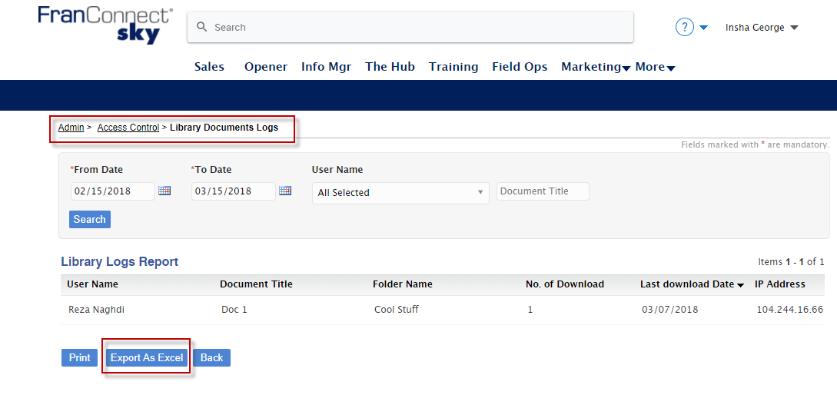

To access the **News Logs.**

1. From **Admin**🡪 **Access Control**, click on **News Logs** .
2. Select the dates.

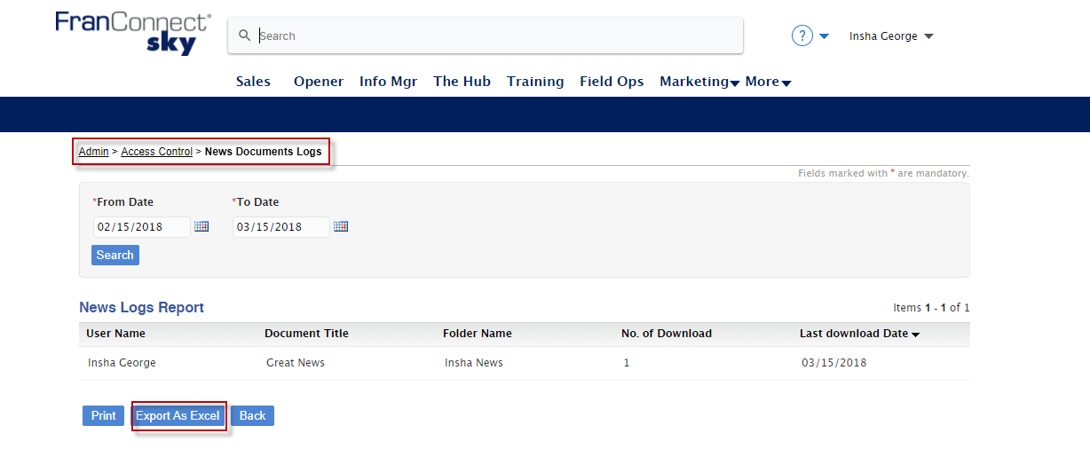

Additionally these logs can be exported to excel for reporting.