**Accessing Archived leads.**

During data cleanup you may find that archiving leads is the best way to manage old leads and duplicate leads. But every now and then, you also would want to access these archived leads for anything from reference to audit purposes.

This can be done by selecting the radio button for **Archived Leads** under the **Search** Tab in **Sales** to access the Archived Leads.

You can select **Search** after filling out or keeping the filters blank.

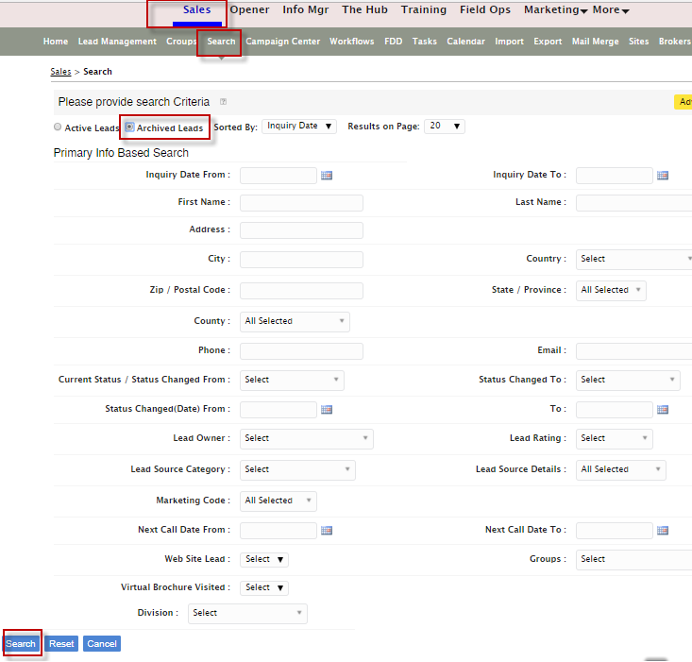

From the Archived Lead Summary page, you can check mark the desired leads and move to Active or Delete.

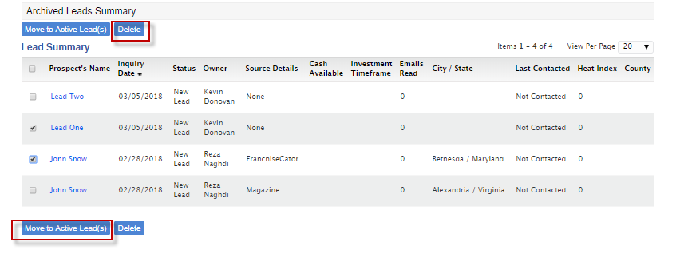

You can also click on lead to access the data or point the cursor to the lead and review the contact data.

