**Add Tabs in Info Mgr- Manage Form Generator**

Organizations like to manipulate their own Info Mgr application by adding more Tabs and fields to meet their business needs. This is convenient to add more data and details regarding the franchise location by Corporate.

FranConnect system is so easily customizable keeping the users at ease when retrieving and reviewing records.

In this article, we will discuss about how to configure these Tabs and fields from **Admin** for **Info Mgr**.

You can start of by going under **Info Mgr** in **Admin**.

1. Click **Manage Form Generator** and then click **Continue.**

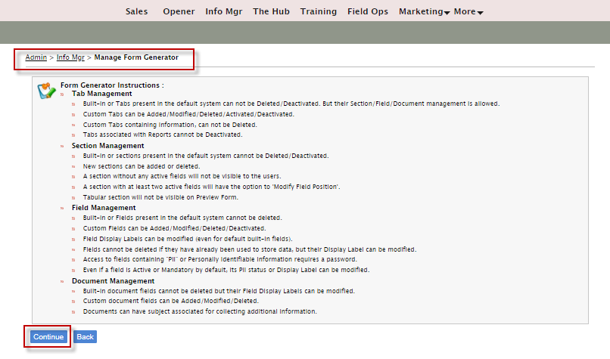

1. Click **Add Tab,** Enter **Display name** and other details and **click Save.**

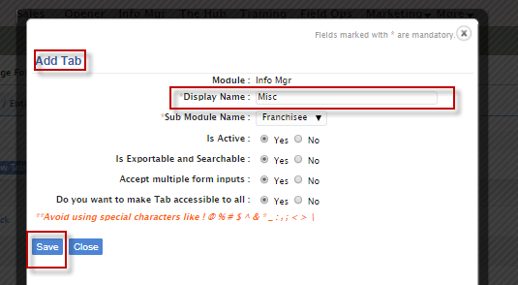

1. Click on any **Tab,** and **Add a section or Add New Field** to an existing section**.**
2. Select Display Type when adding a new field.
3. Click **Add**

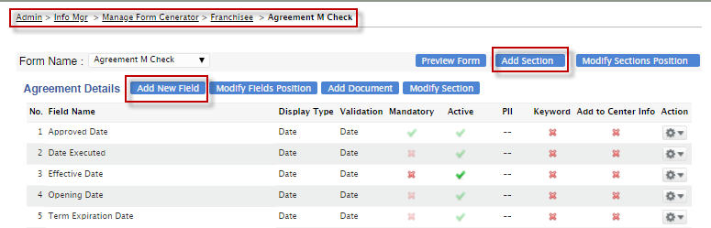

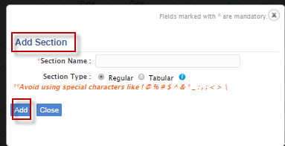

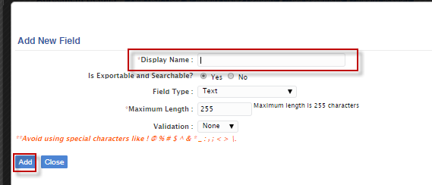

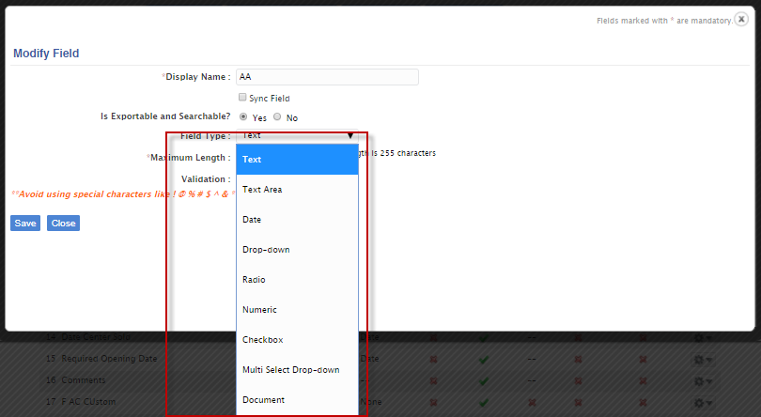

Additionally, you can rearrange the fields by clicking **Modify Field Position.**

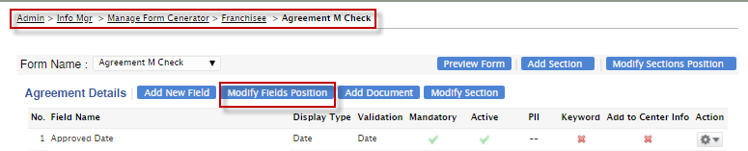

Select and Drag the fields and Preview and Save

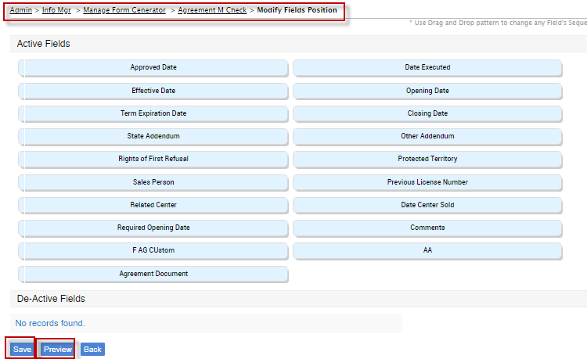

You can also **Add Documents** and save **Field type as Document.**

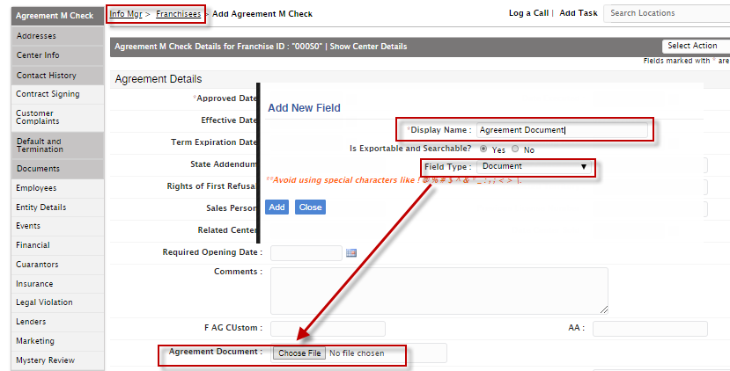

You can **Add Documents** separately **as a section** from **Admin.**

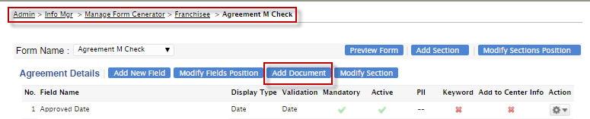

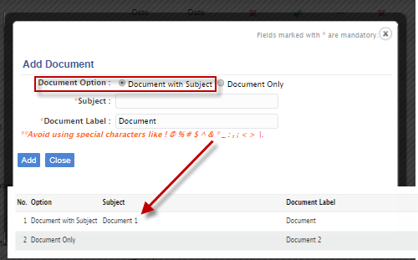

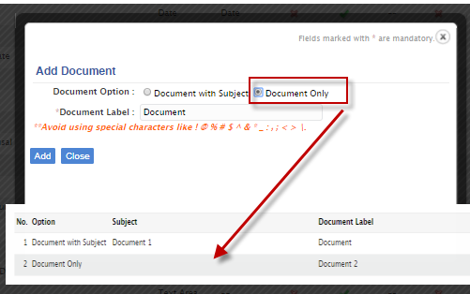

From the **Info Mgr**, **Franchisees** side, **Documents** fields are shown.

