**Sending FDD to leads through the Mobile app in Android**

A successful organization is always looking to develop business all over the country and internationally. And communicating with leads is crucial for success in a fast-growing competitive world.

In a world where everything is controlled through your fingertips by either a click or a swipe, and paper is fading into history, Mobile versions of the system have come very handy. Users no longer should wait and login into the desktop version to accomplish tasks.

While Mobile apps are evolving and have its limitations, it still meets the immediate needs.

In support of these changes and growth, FranConnect’s latest Mobile App now allows lead owners to send FDDs to leads conveniently without any postponements to bring in supreme development of their business.

In this article, we will discuss about sending FDD to leads through the **FranConnect Sky App**.

You can start of by logging into the App.

1. From **Sales**🡪 **Lead Management**, click on a lead under Lead Summary.
2. From the Primary Info page, click on three vertical dots on the right

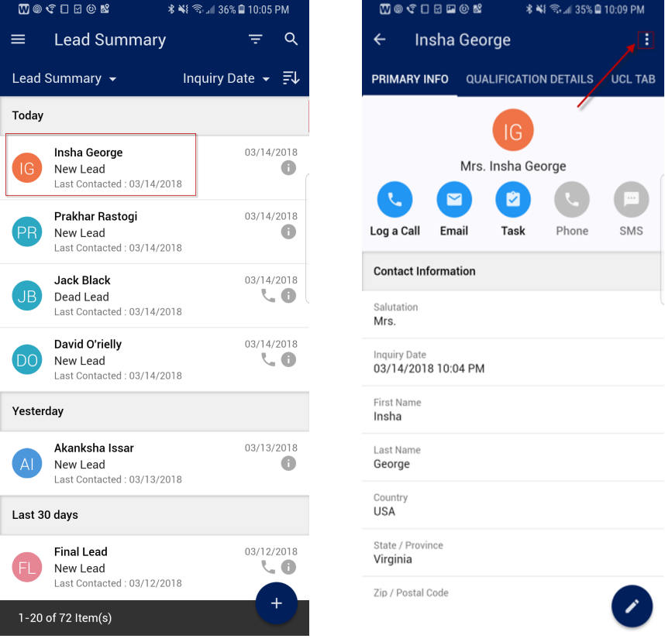

1. From the drop down select **Send FDD Email**

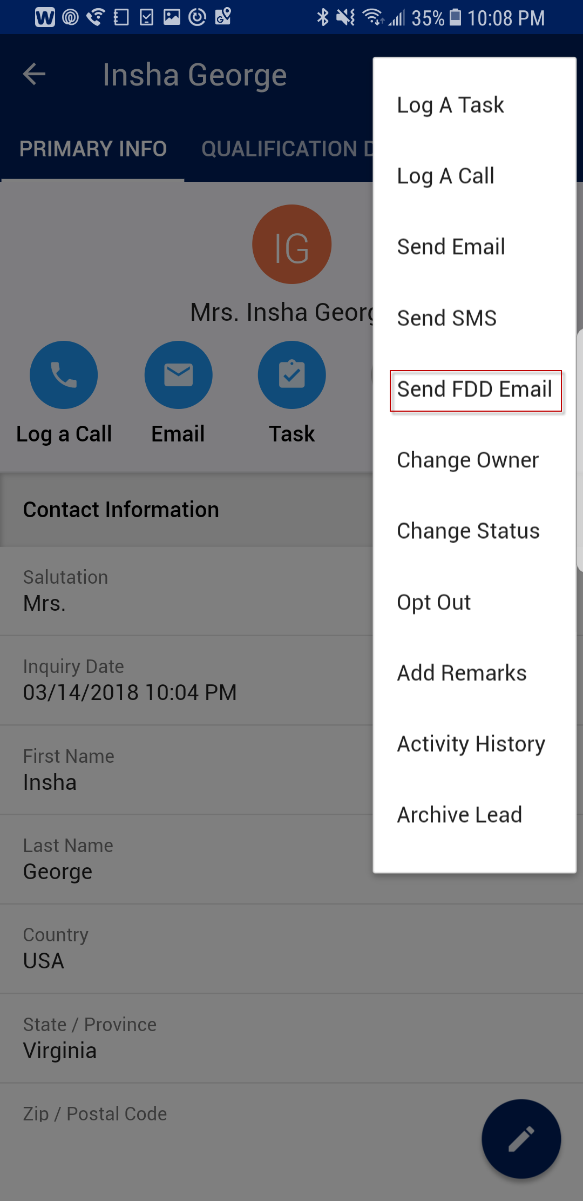

1. From Send FDD screen, you can also check mark to send FDD to co-applicants and click the arrow to hit send.

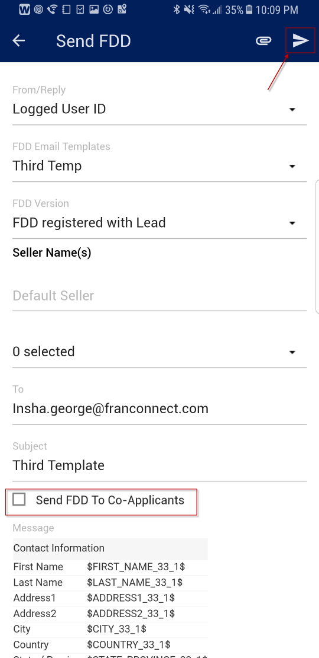

1. From the **FDD Lead Summary page**, the system records, FDD was sent.

