**Roles permission in library folders and documents**

In FranConnect, Roles help you designate privileges (responsibilities) to users. This ensures that users only have access to those system functions that are necessary for the completion of their job.  Because it’s important to regulate and control privileges, we’ll look at how this can be achieved.

The FranConnect system has several predefined roles (e.g. Corporate administrators, default corporate role, default regional role, default franchise role), and gives you the ability to create customized roles.

Roles are convenient when providing permission to access Library folders and Documents in **The Hub.**

In this article, we discuss how Roles and privileges can be regulated for the access in Library.

We will look at how Roles can be regulated at a Folder, Sub Folder and at Document level. By Default, the Corporate Administrator Role is check marked at Folder and Sub-Folder levels.

**At Folder Level**

1. From **Admin**, click **The Hub** from the left, Select **Library**,
2. Select a Folder from the Left, Click **Modify**.

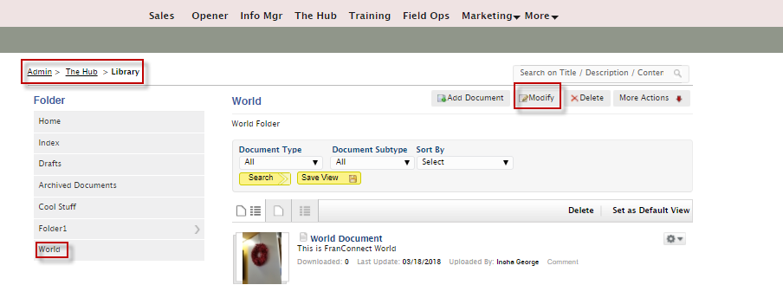

1. From the Modify Folder screen, Select **No** for “**Do you want to make this Folder   
   accessible to all?**”. And choose various roles from different levels of roles.

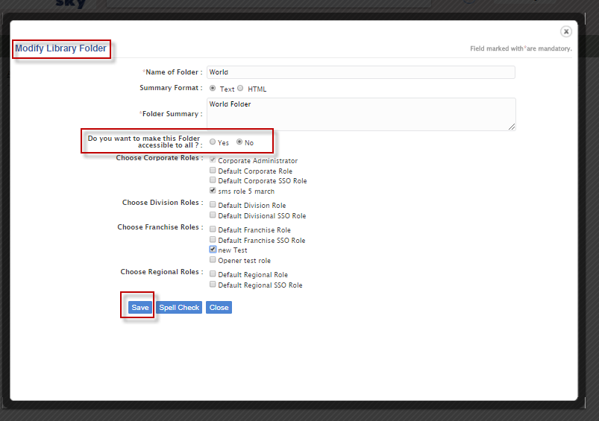

1. Click **Save**.

When accessibility of the Folder is limited to the selected Roles, all subfolders and documents under that Folder falls under that selected accessibility unless those Documents are marked **Protected** completed.

You can see “**Do you want to make this Folder accessible to all?**” in the sub-folder is greyed out.

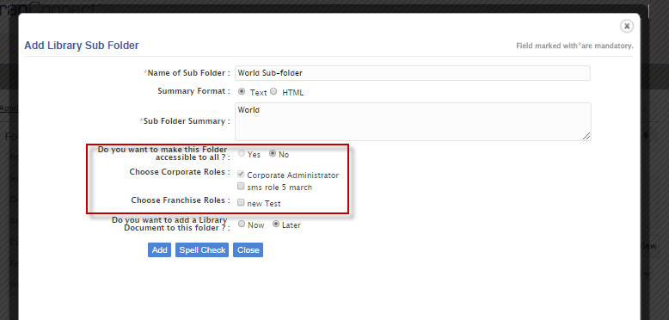

**At Sub Folder level**

1. From the Sub Folder screen, click **Modify**.

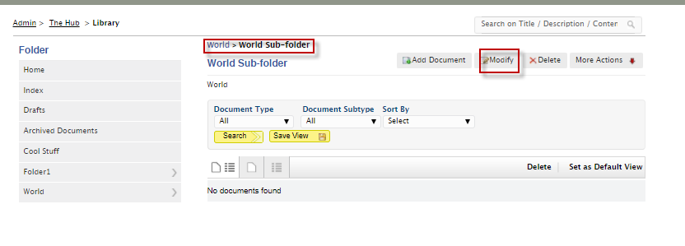

1. As “**Do you want to make this Folder accessible to all?**” is selected No, select any role.

If the roles are unselected, then no user from the roles can view the sub-folder and its documents except the check marked default role.

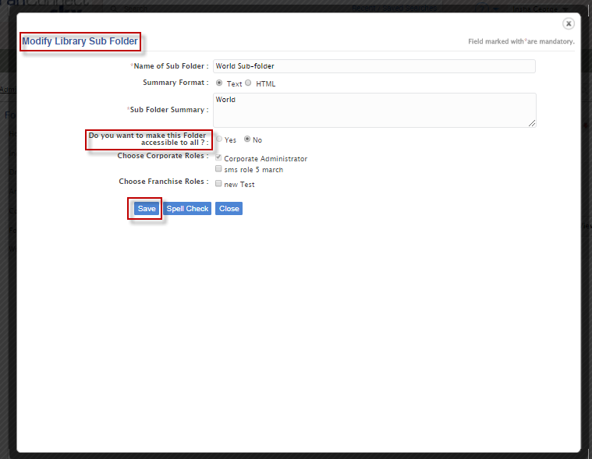

**At Document Level**

A Document’s accessibility is either **Public** or **Protected.**

Regardless of any accessibility from the Folder level or Sub Folder level, if the Document is **Protected**, no user other than Default Role-Corporate Administrator can view.

