**Manage product inventory in Shop -ordering out-of-stock items.**

All franchisors — big, small, or in‐between — require consistency in the products sold under their brands. Product standards and specifications are one of the keys to controlling product consistency.

Franchisors set product standards and specifications, which means that they tell their franchisees what type and quality of products to buy.

Some franchisors give franchisees a list of approved suppliers from whom they can buy their items directly. If the approved suppliers sell only the products permitted by the franchisors — without unlicensed substitutes— franchisors can regulate over the superiority of the products sold under their brand.

FranConnect system offers a section on Product inventory, Suppliers, Shop tab under the Marketing application.

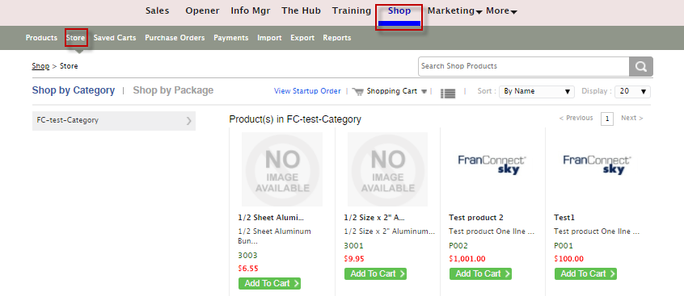

In this article, we discuss, how to manage Product inventory from the **Shop**.

1. Click the **Product** from the **Shop** Interface.
2. From the Action Gear, click **Modify Inventory** for the **Manage Category.**

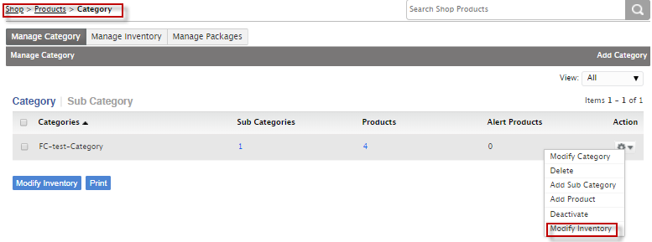

1. Enter **Quantity in Hand, Reorder Quantity** and **Alert Quantity.**

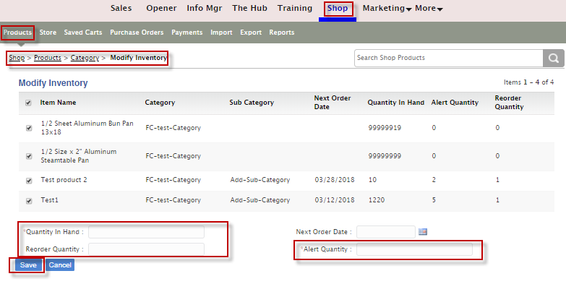

1. Click **Save.**

**To Deactivate Products**

1. Under **Manage Inventory** Tab, check mark a **Product No**. and click **Deactivate**.

