**Profit and Loss Statements and Reporting**

The **profit & loss** (P&L) statement is one of the three primary financial statements used to assess a company's performance and financial position (the two others being the balance sheet and the cash flow statement).

Profit and loss **management** is **managing** income (incoming money) and expenses (outgoing money) to ensure that a business earns a net operating profit. Usually, profit and loss **management** deals with profit and loss reports (commonly called **P&L** reports)

FranConnect System’s Finance application offers a Tab for adding monthly Income and expense by the franchisee which is later evaluated through reports by the Corporate.

In this article, we will discuss how to add a Statement and run a report in Finance.

As a Franchisee, you can start of by clicking and entering **New Profit/ Loss Statement** under **Profit & Loss Statement** in **Finance.**

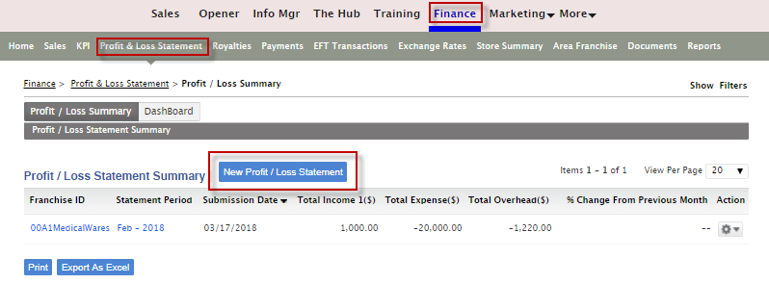

You can enter the Income, Expense and Overhead details and click **Save**.

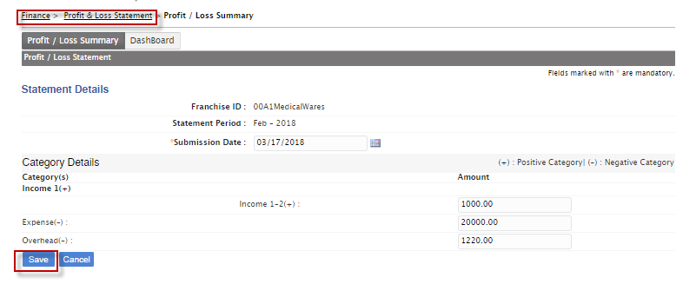

Additionally, you can run a report for the Profit & Loss Statements either as a Corporate or Franchisee.

From the **Reports** Tab, you can select the **Profit /Loss Statement Report**

You can select various filters:  **Search By, Area/Region, Division, Franchisee Status and Report Period.**

Click **Save View** to retain these filter options.

Click **View Report.**

