**How to add KPI (key performance indicators) Goals in Finance**

**KPI** **(key performance indicators)** is a blanket term for the types of markers that businesses use to measure performance in a variety of areas, from marketing to HR to **finance**. Keeping close tabs on your small business' **financial** performance is essential to long-term success.

FranConnect System’s Finance application offers a Tab for adding KPI goals to collect measures and calculate metrics.

In this article, we will discuss how to add KPI goals for Franchise locations and run a report from the Dashboard in Finance.

You can start of by clicking **KPI** in **Finance.**

1. Click **Add Goals** from the **Goals** Tab

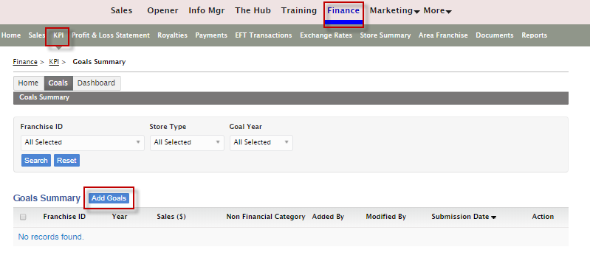

1. Select **Goal Year** from the Drop Down and the **Franchise ID.**
2. Enter the data for each month of the year
3. Click **Save.**

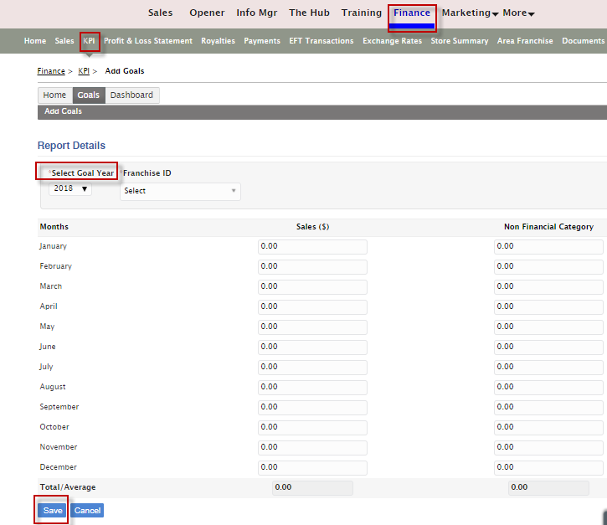

To run reports from the **Dashboard** Tab.

The Dashboard provides a breakdown of the Financial and non-Financial Indicators Goals vs the Actuals as well as a graph. It also helps to compare with the present and previous year’s Sales Growth.

You can either **Print** or **View in PDF.**

1. Click **Dashboard** Tab and enter the **Franchise ID, Select Year** and click **Get Dashboard.**

